**ELK Stack – NK 14/10/2017**

**Elastic search installation : http://localhost:9200/**

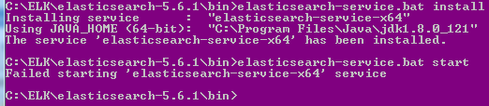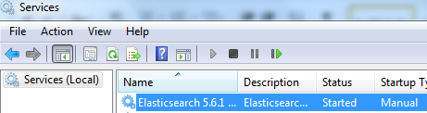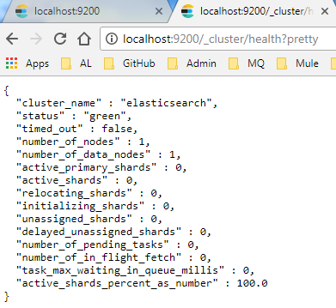

**Kibana installation**

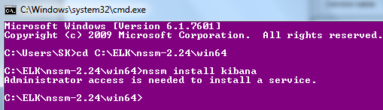

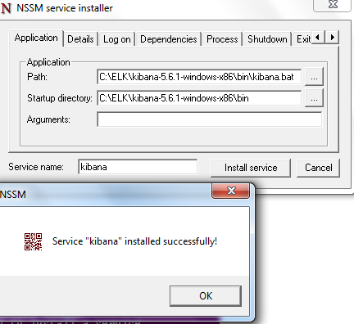

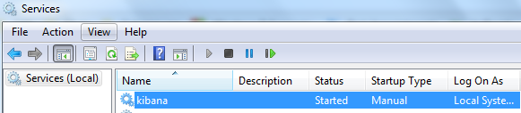

[**http://localhost:5601/app/kibana#/management/kibana/index?_g=()**](http://localhost:5601/app/kibana#/management/kibana/index?_g=())

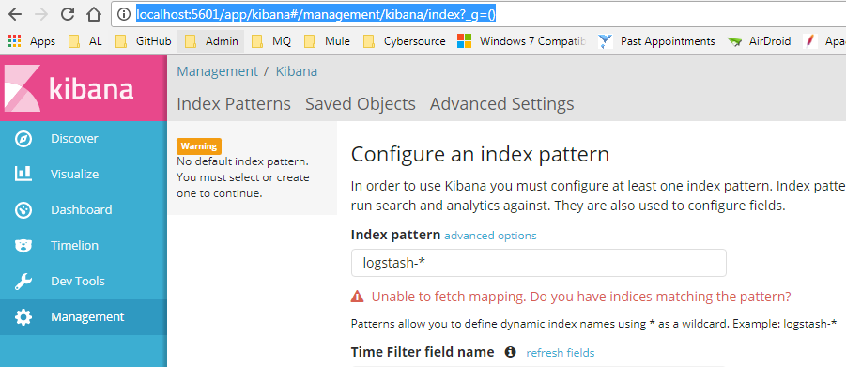

**Logstash installation**

**Config file**

**Location :: C:\ELK\logstash-5.6.1\bin**

input {

file {

path => 'C:/ELK/logs/*'

}

}

output {

elasticsearch {

hosts => ["localhost:9200"]

index => "logstash-%{+YYYY.MM.dd}"

}

stdout { codec => rubydebug}

}

